Aleksas Murauskas 260718389

ECSE 422 Written Assignment #1

1. A scenario where fault masking is appropriate is one where the application has a long fault latency. For example, if a Space shuttle has multiple computers running the same calculations, one computer can send an incorrect result, the other computer’s correct calculations will overlap. A scenario in which fault masking is not the preferred is when the application has a short fault latency. Three disadvantages of fault masking are you are unable to detect faults, locate faults, and recover from faults.
2. The four main causes of faults are:
   1. Specification layer: incorrect algorithms or data structures,
   2. Implementation: bad component selection, poor construction and software coding mistakes
   3. Components: A component is falsely manufactured or failed
   4. External Factors: damage from use, operator misuse, or interference from electromagnetic waves

|  |  |
| --- | --- |
| CAUSES SOFTWARE FAULTS | CAUSES HARDWARE FAULTS |
| Specification, Implementation | Implementation, External factors, components |

1. Critical component of the ISS: I would choose the design of a longer Error latency. The extension of the period between the error’s appearance and a system failure, would allow time for the ISS crew to discover the source of the error and/or fault before a large system failure occurred. Since the time between supply launches for the ISS are sparse due to the cost, a long amount of time between for error latency, would allow the fewest number of supply launches possible without any system failures.
2. A list of failures for a library system stored on computer disks include

|  |  |  |
| --- | --- | --- |
| Failure | Failure Type | Design Feature to minimize these problems |
| Wifi Signal Electronic Interference | Natural | Use wired connection |
| Operator accidently deletes key data | Human | Add “are you sure” notices before deletions |
| A disk is scratched, caused some data to be corrupted | Equipment | Have storage backups, so data is not lost until disk is replaced |
| Water leaks onto a part of the system causing a disk to be destroyed | Natural | Have storage backups, so data is not lost until disk is replaced |

1. The expression of Reliability of the figure is

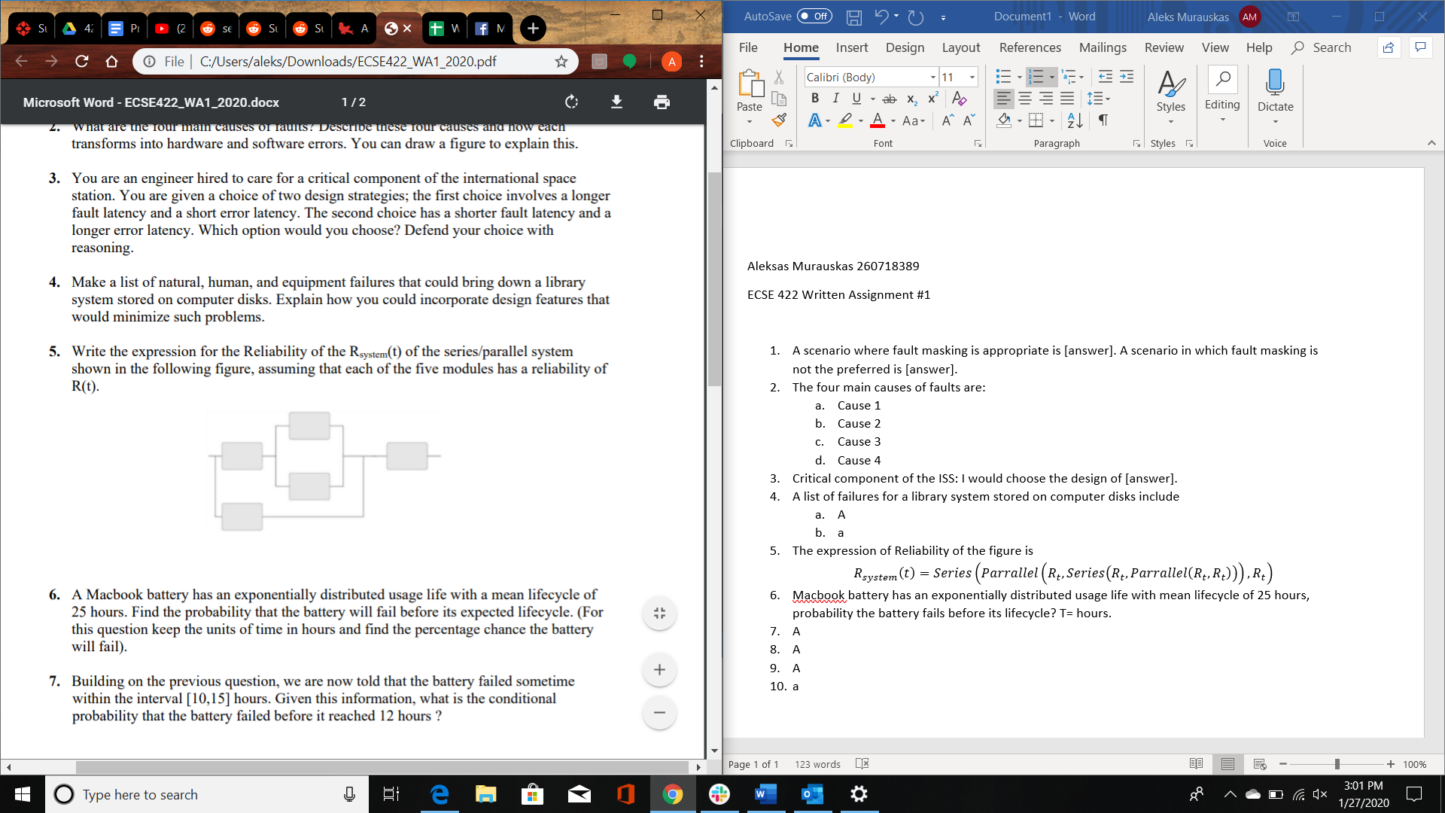

$$Reliability of Series R= R_{t}*R_{t}$$

$$Reliability of Parrallel R=P_{s}=1-{\left(1-R_{t}\right)}^{2}$$

$$R_{system}\left(t\right)=Series\left({Parrallel\left(R_{t},Series\left(R_{t},Parrallel\left(R_{t},R_{t}\right)\right)\right),R}_{t}\right)$$

$$R_{system}\left(t\right)=Series\left({Parrallel\left(R_{t},Series\left(R_{t},1-{\left(1-R_{t}\right)}^{2}\right)\right),R}_{t}\right)$$

$$R_{system}\left(t\right)=Series\left({Parrallel\left(R_{t},R_{t}\left(1-{\left(1-R_{t}\right)}^{2}\right)\right),R}_{t}\right)$$

$$R_{system}\left(t\right)=Series\left({1-\left(1-R_{t}\left(1-{\left(1-R_{t}\right)}^{2}\right)\right)\left(1-R_{t}\right),R}_{t}\right)$$

$$R_{system}\left(t\right)=R_{t}\left(1-\left(1-R_{t}\left(1-{\left(1-R_{t}\right)}^{2}\right)\right)(1-R_{t})\right)$$

1. Macbook battery has an exponentially distributed usage life with mean lifecycle of 25 hours, probability the battery fails before its lifecycle? T= hours.
$$Mean Life Cycle=\frac{1}{γ},γ =\frac{1}{25}$$

$$CDF=1-e^{-γt}=1-e^{\frac{-1}{25}*25}=0.632=63.2\%$$

2. The battery has died between 10 and 15 hours. Given this what is the conditional probability that the battery failed before it reached 12 hours.
$$CDF_{range}= CDF_{15}- CDF_{10}=\left(1-e^{-\frac{1}{25}*15}-1-e^{-\frac{1}{25}*10}\right)=0.451-0.329=0.122$$

$$CDF_{<12}=CDF_{12}-CDF_{10}=0.381-0.329=0.052$$

$$Conditional Prob=\frac{CDF_{<12}}{CDF_{range}}=\frac{0.052}{0.112}=0.464=46.4\%$$

3. A mission critical valve has two modes of failure, leaking and blocked.

3 states must be used to detect and correct faults, since there are multiple versions of failure. This would increase the cost of the eventual system design, as more modules are needed to account for all types of failure.

1. The advantage of a self-purging redundancy over N-modular redundancy is a reduced hardware cost. Self Purging Redundancy removes a Erroneous module, while N modular requires a number of passive spares to be swapped in. So N-modular redundancy results in more modules, resulting in a higher cost.

An example system could be a airplanes navigation system. When the computer system computes the navigation distance from certain points, N multiple modules run the same calculations and then results all are funneled through a Voter, this voter outputs the most received output, as well as a signal to a number of switches, one for each module. If the voter receives an input that disagrees with the majority, an fault has been discovered and that module is disconnected from the voting process until the fault can be repaired.

1. 3 Switches, 3 Voters in case a voter fails

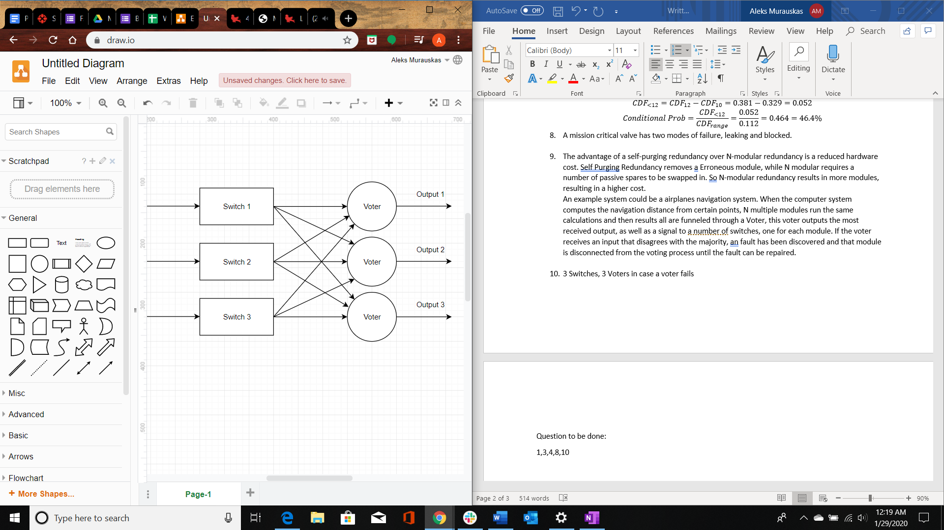

Question to be done:

8